**India Air Quality**

According to ***The Air (Prevention and Control of Pollution) Act, 1981***, “Air pollution is the presence of any solid, liquid, or gaseous substances in the atmosphere in such concentration as may be or tend to be injurious to human beings or other living creatures or plants or property or environment”.

The National Air Monitoring Programme (NAMP) identifies four air pollutants viz., Sulphur Dioxide (SO2), Oxides of Nitrogen as NO2, Suspended Particulate Matter (SPM) and Respirable Suspended Particulate Matter (RSPM/PM10). On an annual basis, the permissible limit of Respirable Suspended Particulate Matter (RSPM/PM10) is 60 ug/m3 as per the national ambient air quality monitoring standards. Similarly, the permissible limit for NO2 and SO2 is 40 ug/m3 an d 50 ug/m3 respectively. This report analyses the air quality data from the year 2003 to 2013.

**SO2 Emission**

As per country-wise world rankings, India was found at the top position in emitting sulphur dioxide (SO2) as it has the maximum hotspots. According to an analysis of a National Aeronautics and Space Administration (NASA) data released by environmental NGO Greenpeace.

**India has more than 15 percent of all anthropogenic sulphur dioxide (SO2) hotspots** in the world detected by the OMI (Ozone Monitoring Instrument) satellite.

The**largest source of SO2 in the atmosphere is the burning of fossil fuels in power plants and other industrial facilities.**

**Top 10 worst emitters of SO2 pollution**

The list of major SO2 emission hotspots in India from 2003-2013 are Nasik in **Maharashtra,** Lucknowin **Uttar Pradesh,** and Ahmedabad in **Gujarat** on the top 10 most polluted list with ‘very high’ emission of SO2 and ‘poor’ air quality index.

**NO2 Emission**

NO2 is a dangerous pollutant in itself and also contributes to the formation of PM2.5 and ozone, two of the most dangerous air pollutants.

The main source of nitrogen dioxide (NO2) resulting from human activities is the combustion of fossil fuels (coal, gas and oil) especially fuel used in cars. It is also produced from making nitric acid, welding and using explosives, refining of petrol and metals, commercial manufacturing, and food manufacturing.

****Worst emitters of NO2 pollution**

The list of the largest NO2 hotspots in India from 2003-2013 includes West Bengal, Maharashtra, and Uttar Pradesh.  
Cities such as Kolkata, Navi Mumbai Lucknow, and Ahmedabad also feature prominently in the list of 50 NO2 hotspots due to transport-related emissions.

**Respirable Suspended Particulate Matter (RSPM)**

RSPMs are more dangerous to health because they are much smaller than Suspended Particulate Matter (SPM), an umbrella term for all such substances with deleterious consequences, that are less then 100 micrometres in diameter.

These superfine particles can penetrate deeper into the lungs, making those who breathe poisonous air more vulnerable to heart diseases, chronic bronchitis, asthma and even lung cancer. Indian cities exceed – sometimes way beyond acceptable limits – national and international standards for air pollution. The prescribed National Ambient Air Quality Standard is 60 micrograms per cubic meter.

As seen from the Heat map, we have **Punjab** which has the highest level of rspm, followed by **Delhi**, and **Uttar Pradesh**. Where as *Sikkim*, *Mizoram*, and *Pudhucherry* have lowest level of respm concentration.

**Top cities which have exceeded the prescribed limit of 60 µg/m3**

**Suspended Particulate Matter (SPM)**

Suspended particulate matter (SPM) or particulates – are microscopic solid or liquid matter suspended in the Earth's atmosphere. Particulate matter is the sum of all solid and liquid particles suspended in air many of which are hazardous. This complex mixture includes both organic and inorganic particles, such as dust, pollen, soot, smoke, and liquid droplets. These particles vary greatly in size, composition, and origin. It consists of microscopically small solid particles or liquid droplets suspended in the air. The smaller the particles, the deeper they can penetrate into the respiratory system and the more hazardous they are to breathe. Particulate matter is primarily a problem in the wintertime in the Bay Area, when seasonal wood-burning makes a substantial contribution. While Inhalable coarse particle is found near roadways and dusty industries, fine particles can be directly emitted from sources such as forest fires, or they can form when gases emitted from power plants, industries and automobiles react in the air.

**Causes of Particulate Matter**

* Volcanoes, Dust storms, Forest and grassland fires, Living vegetation, Sea spray, Tornado’s and hurricanes.
* Coal Combustion, Oil Combustion, Wood combustion, Construction, Road dust, Power plants, Industrial, Agriculture, Livestock, Deforestation, Por condition of anti-pollution technology, and Tobacco smoke.

As seen from the above Heat map, we have **Delhi** which has the highest level of spm, followed by **Uttar Pradesh, and Uttarakhand**. Where as *Goa, Keral*, and *Pudhucherry* have lowest level of spm concentration. . And if one person dies prematurely every hour in Delhi due to high SPM levels, the death count in Uttar Pradesh and UttaraKhand can well be imagined. Although, both RSPM and SPM concentration are very low in Pudhucherry.

**Top cities which have exceeded the prescribed limit of 60 µg/m3**

The ambient air quality in even smaller cities and towns is deteriorating alarmingly and, in some cases, much worse. In Meerut, for example, the maximum average level of suspended particulate matter (SPM) is 588.3 matched the highest levels recorded in Delhi. The main reason for this is a sharp rise in polluting motor vehicles and mismanagement of public transport. Rogue industrial units also play a hand. Although data about rising levels of air pollution is available, there are no programmes in any of these cities to counter the emerging public health disaster.

**TYPES OF AREAS AND AIR POLLUTION**

**Density of areas in India**

The below three maps depicts the states which has the types such as Industries, Residential, and Sensitive.

Industrial Area Residential Area Sensitive Area

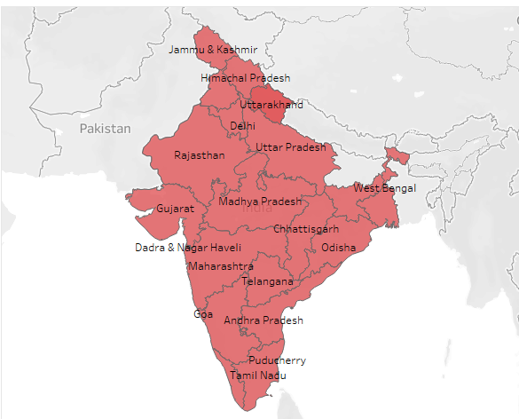

Most of the states are Industrialized except North-eastern states like Bihar, Sikkim, Meghalaya, Nagaland and Mizoram. Whereas the sensitive states are from Southern parts of India like Kerala, Andhra Pradesh, Telangana, travel through Central parts like Maharashtra, Madhya Pradesh, and reaches to Northern parts Uttar Pradesh and Himachal Pradesh.

**Emission of SO2 and NO2 in types of areas Concentration of RSPM and SPM in types of areas**

* NO2 and SO2 emission levels from Residential area is in higher range than Industrial area, followed by Sensitive areas.
* Compared to SO2, larger range of emissions of NO2 pollution causes serious health issues.
* Likewise, SPM and RSPM concentrations are higher in Residential, followed by Industrial and Sensitive areas.
* Compared to RSPM, SPM exceeded the permissible range, which is a serious issues now a days the metropolitan cities are facing.

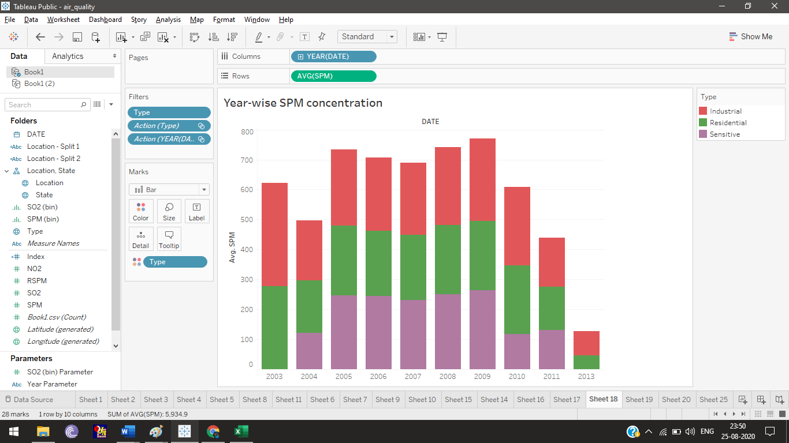

Always SPM concentration reaches beyond its average limit. From 2003 to 2010 its level was above 500 micrograms (avg) In 2011 and 2013 its level decreases below 500 micrograms (avg).



There is a gradual increase of RSPM concentration from 2003 to 2005 and then considerable decrease in 2006 and 2007, in 2008 again increased and reached top in 2009 and then gradual decrease from 2010 to 2013. Here we note that all types of areas were gradually increased and then decreased. There is no notable decrease in any of the 3 types of area.

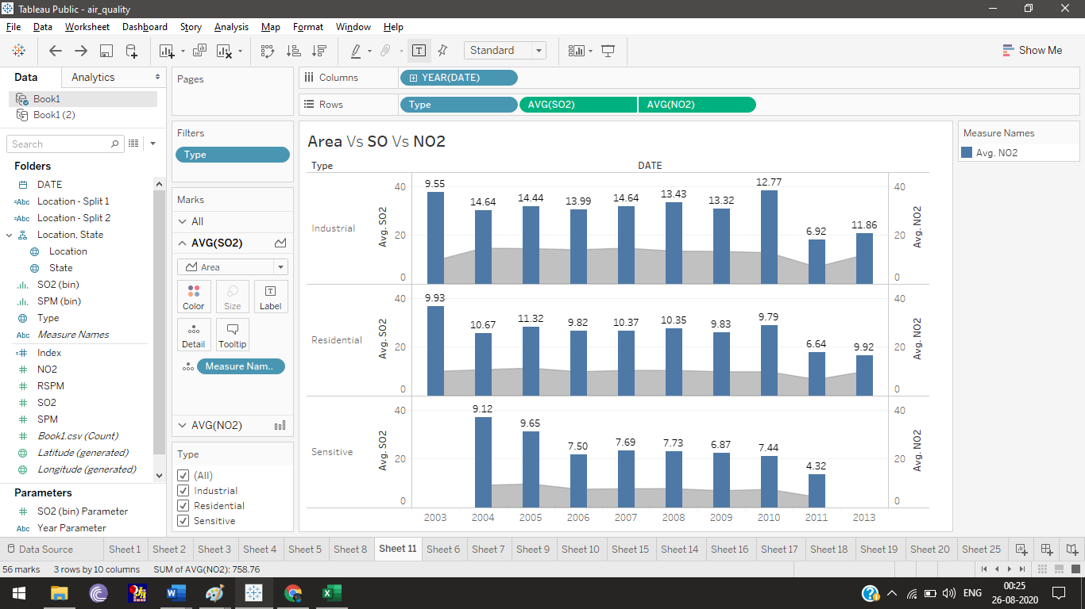**Types of area vs SO2 vs NO2 with respect to year**

* This chart clearly depicts the year wise SO2 and NO2 records in each 3 types. Here the numbers above the bar represents the average value of SO2.
* Pollution from residential area increased in higher range year by year than Industrial area.
* Pollution level of sensitive area is lower than other two areas.
* SO2 and NO2 level started increasing since 2004. We can clearly see the decreasing trend of both levels from 2010 onwards.

**Types of area vs RSPM vs SPM with respect to year**

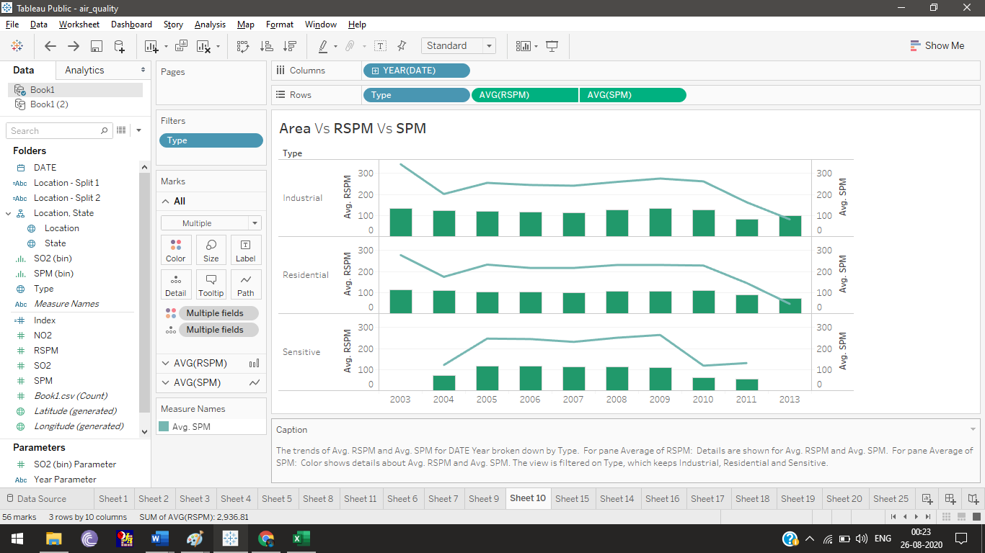

* This chart clearly depicts the year wise RSPM and SPM records in each 3 types.
* Concentration level of both RSPM and SPM are larger in residential area.
* Pollution level of sensitive area is lower than other two areas.
* Here we see the increasing trend from year 2003 onwards. Maximum concentration of RSPM and SPM in air recorded from 2007 to 2010.

**SUMMARY**

According to the analysis, air pollution is a huge public health concern, with 91 percent of the world's population living in areas where outdoor air pollution exceeds guideline limits by the World Health Organization (WHO) and as a result, **4.2 million people die prematurely every year.**

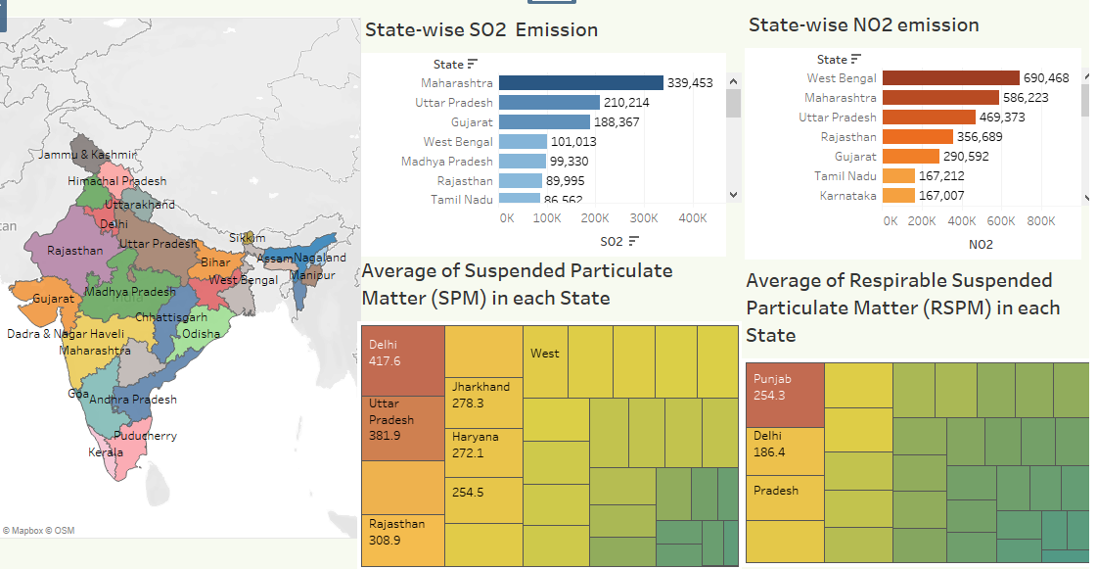

**Maharashtra, Uttar Pradesh, West Bengal, Gujarat, Delhi, Punjab, Rajasthan, and Tamilnadu have in the serious circle of air pollution, which means cities belongs to this states are worst emitters of SO2 and NO2 pollutions. Concentration of toxic elements in the form of minute dust particles are larger in the cities of the above states causes various health issues and higher mortality rate. The present observation shows a decreasing trend in pollution levels. A decreasing trend may be attributed to various interventions that have taken place over the last decade such as shutting down of hazardous industries, reduction of sulphur content in petrol and diesel, use of cleaner fuel for transport (CNG) and domestic (LPG) purposes.**

The first comprehensive study on the link between air pollution and its health effects, conducted by the World Bank in 1995, held SPM responsible for maximum deaths and health problems in 36 Indian cities. The Centre for Science and Environment, New Delhi, repeated the study in 1997 using data for 1995, and found that one person dies prematurely every hour in Delhi due to high SPM load. It also found that premature deaths due to high SPM levels had increased by 28 per cent in three years in the cities.

In December 2015, the Ministry of Environment, Forest and Climate Change, had introduced for the first time SO2 emission limits for coal power plants with an initial deadline to retrofit technology to control SO2 emissions from power generation by December 2017. At the request of the Ministry of Power and power plant operators, this was later extended till December 2019 for power plants in Delhi-NCR and till 2022 for some other power plants across the country through a Supreme Court order.

There are clear solutions to the global air pollution crisis. First and foremost, with coal the number one source of NO2 emissions, governments need to rapidly move their energy systems away from reliance on coal and towards renewable technologies. For those regions and cities whose primary source of air pollution is transportation, comprehensive plans to move away from combustion engine vehicles, particularly diesel, to electric-powered public transport systems will help to provide clean air.

Due to industrialization, year by year emission of toxic pollutants level raises in the air. Government taking lot of measure to control air pollution through programs like National Clean Air Program (NCAP). It provides a roadmap to prevent, control, and reduce unhealthy air pollution.

Here I forecasted one of the main element SPM which causes the air gets more polluted. The SPM levels steadily rising since 2007After the sudden fall from 2011 there is a considerable amount of increases in SPM level up to 2018. According to that forecast indicator, the probability of SPM level reaches 29,691 to 400k in 2018.